Name: Aidan Sharpe

This assignment is to be done individually. Please use complete sentences for your responses.

Note that you will need to use the textbook as a reference guide to answer many of the questions. For a few of the questions you may also require to research items on the Internet and for some questions you will need to have your laptop connected to the Internet to capture your results.

1. (12 points total) Given the circuit switched network below that has 4 circuits on each link.

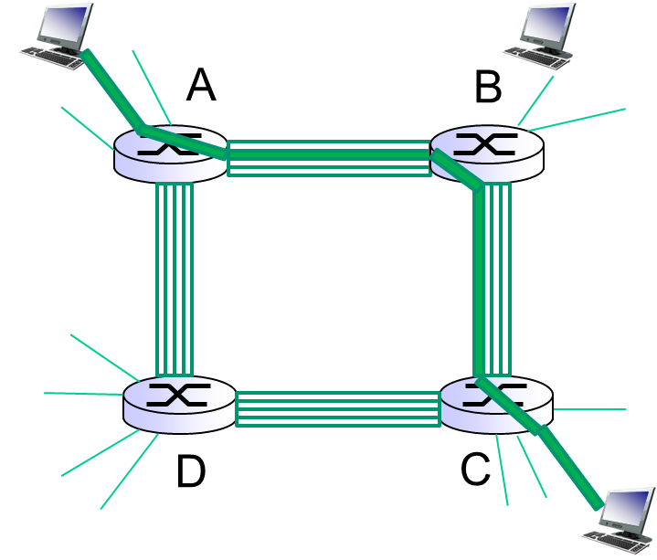

* 1. **What is the maximum number of simultaneous connections that can be in progress at any one time in this network?**

16

* 1. **Suppose that all connections are between switches A and C. What is the maximum number of simultaneous connections that can be in progress?**

4

* 1. **Suppose we want to make 4 connections between switches A and C, and another 4 connections between B and D. Can we route these calls through the four links to accommodate all 8 connections? Describe the connections that make this possible or impossible?**

Since all packets going from A to C must travel to switch B or D, and similarly, all packets going from B to D must travel through switch A or C, and all 4 links would be used, this specific 8 connection scenario is impossible on this network.

1. (8 points total); 2 points for showing your results) Visit the site <http://tracert.com/trace_exe.html> or[www.traceroute.org](http://www.traceroute.org) and perform traceroutes from two locations in the same country on the same continent to ip address 75.75.75.75 as your destination address in the US. Note occasionally some of the country entries are not reachable. Find a country with (2) working links. Cut and paste your traceroutes ***and include them with your handed in assignment.***
   1. **How many links are the same in the two traceroutes?**

I found two working German links. Both took 11 hops to reach 75.75.75.75

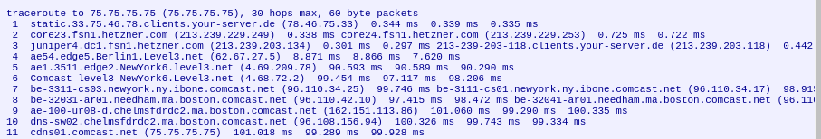

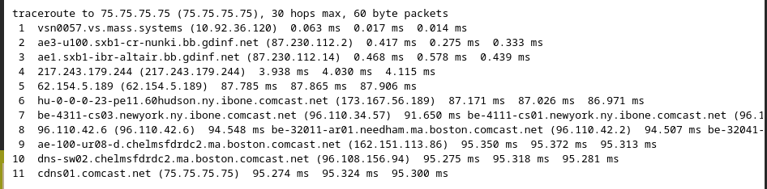

* 1. ***Identify* the longest link in your output (transatlantic link). Is the same transatlantic link used for both traceroutes?**

The transatlantic link occurred on hop #5 for both websites. They took different transatlantic hops, however.

1. **(5 points total) What advantage does a circuit switched network have over a packet switched network?**

Since channels are reserved, in circuit switched networks data does not have to wait at switches.

1. **(5 points total) A router receives a packet on an inbound interface and forwards it to an outbound interface. When packet n arrives there are 14 packets waiting to be forwarded to the same outbound interface. One of the 14 packets is halfway done being transmitted when packet n arrives. What is the queuing delay for packet n? Note that packets are transmitted in order of arrival. Assume packets are 1500 bytes and the transmission rate is 1.5 Mbps.**

13.5*1,500*8=162000 bits 162000/1500000 = 0.108 seconds

0.108 seconds before packet n can begin transmission.

1. **(6 points total) As an application’s message travels through a path on a network**
   1. **What information is added to an application’s message to make it a segment?**

TCP header

* 1. **What is added to a segment to make it a datagram?**

Payload data is added to a segment

* 1. **What is added to a datagram to make it a frame?**

Frame headers are added

1. (15 points total) This problem begins to explore propagation delay and transmission delay, two central concepts in data networking. Consider 2 hosts, A and B, connected by a single link of rate R bps. Suppose that the 2 hosts are separated by m meters, and suppose the propagation speed s along the link is in meters/sec. Host A is to send a packet of size L bits to Host B.
   1. **Express the propagation delay, dprop,in terms of m and s.**

Propagation delay is determined by the distance, *m*, divided by the propagation speed, *s*.

* 1. **Determine the transmission time of the packet, dtrans, in terms of L and R.**

Transmission time is determined by the packet length, *L*, divided by the link bandwidth, *R*.

* 1. **Ignoring processing and queuing delays, obtain an expression for the end-to-end delay.**

Dprop + Dtrans = (m/s) + (L/R)

Now suppose that there are (2) WAN links separating hosts A and B using (3) routers. The first WAN links transmission rate is 2 Mbps; the second is 4 Mbps. The propagation speeds=2.5*108 m/sec. The distance of the first WAN link is 4000 Kilometers and the distance of the second WAN link is 600 Kilometers.

* 1. **Draw the network between A and B; include hosts A and B in your picture. Label each WAN link with its transmission rate.**

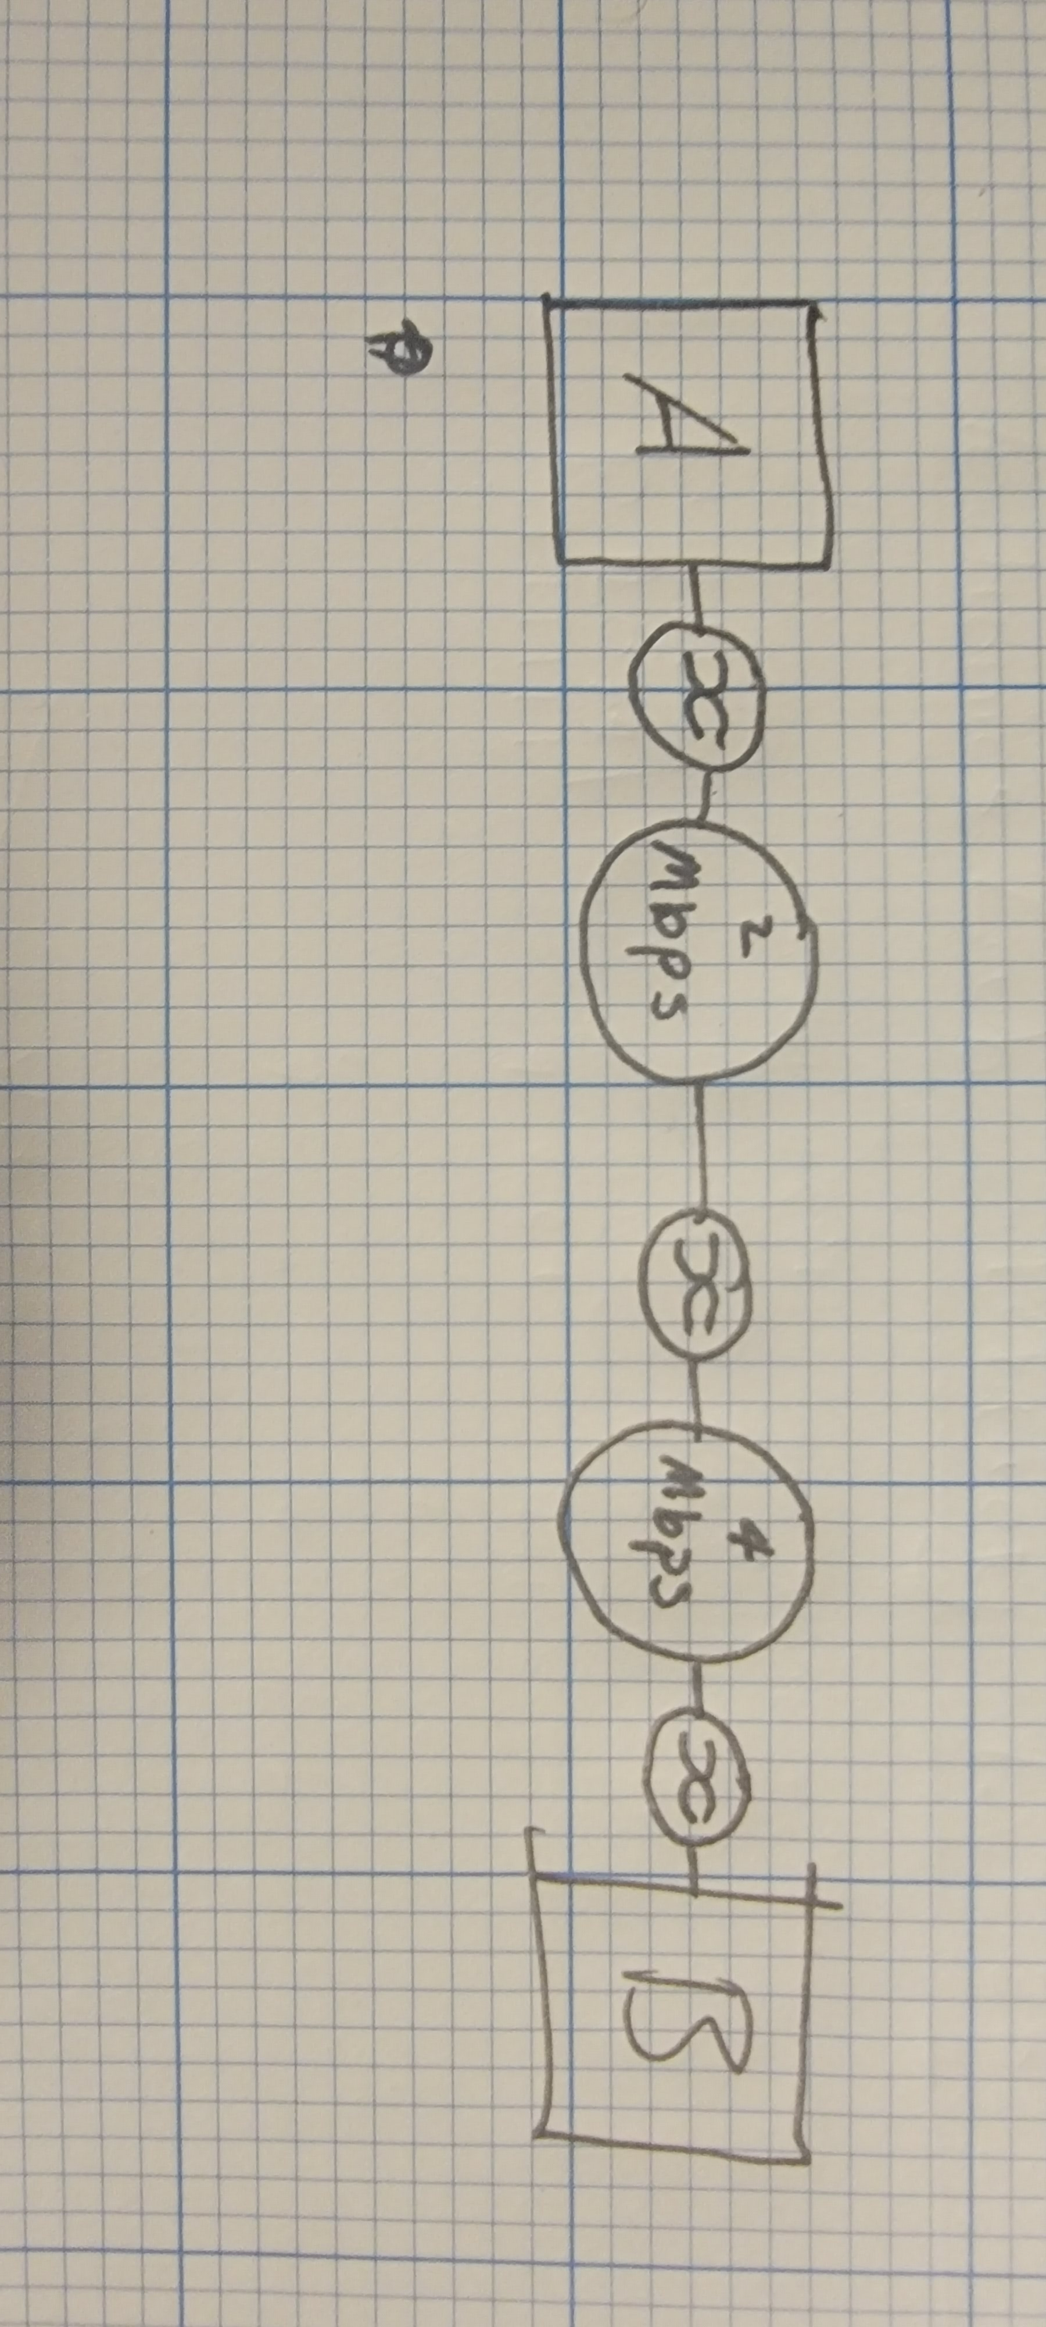

* 1. **Compute the propagation delay for sending (1) 1400 byte packet from over the WAN from A to B. Show your answer in seconds out to at least 4 decimal places.**

dprop=m/s

m1=600 km

m2=4000km

m=4600km

s=2.5*10­8m/s

dprop=4600/2.5*108= 0.0000184 seconds = 18.4 microseconds

1. (10 points total) Answer the following questions.
   1. **What message types have port numbers?**

TCP and UDP me

* 1. What are a server’s port numbers associated with?
  2. **What is the well-known port number for HTTP?**

80

* 1. **What is the well-known port number for SMTP e-mail applications?**

25

* 1. **What are the well-known port numbers for FTP file transfer applications?**

20, 21

1. (6 points total) Answer the following questions.
   1. **How long are Ethernet MAC addresses in bits?**

6 bytes = 48 bits

* 1. **What devices read Ethernet destination MAC addresses?**

Link layer switches read Ethernet MAC addresses.

1. (2, 5 points) The Internet is a large network that continues to grow.
   1. **What does ISP stand for?**

Internet service provider

* 1. **A Rowan student in Philadelphia decides to send a file to another student in Asia over the Internet. The student in Asia uses an ISP that has no network presence in the U.S. Explain how it is possible to send the file using the Internet?**

The point of an internet service provider is to link users to the broader internet. Since all tier 1 are connected through peering, and all ISPs ultimately interface with tier 1 networks, data simply travels up the ranks to the most overarching network and then back down the ranks to its destination.

1. (8 points total) Answer the following questions.
   1. **Distinguish between static and dynamic IP addresses.**

A static IP does not change over time. As long as the service is in use, the IP address will remain constant which can be a good thing when you need to connect to a local computer. Dynamic IPs change over time. One day your laptop might be assigned one IP and the next day you might have a completely different IP.

* 1. **What protocol provides a client PC with its dynamic IP address?**

DHCP (dynamic host configuration protocol)

* 1. **What other configuration information does it provide? Name two.**

Reserved IP addresses, lease duration

* 1. **Why should PCs get their configuration information dynamically instead of manually?**

DHCP ensures that an available, valid IP is assigned.

1. **(8 points total) The authors of the book go to great lengths to use the term link layer switches when taking about layer 2 devices in the OSI model. What distinguishes a “layer 3 switch” from a “link layer switch”?**

Link layer switches use a hardware address to identify devices while layer 3 switches use IP addresses.

1. **(10 points total) Name two, (other than category 5 100baseTX), cable types that can be used to run Ethernet.** 
   1. **Include the maximum distance that these cable types can be used for connecting network components using a transmission speed that you specify.**

Fiber optic – Depending on the quality of fiber optics and the emitter being used throughput and distance can change drastically

Coaxial -Impedance is generally not affected by distance above a certain frequency